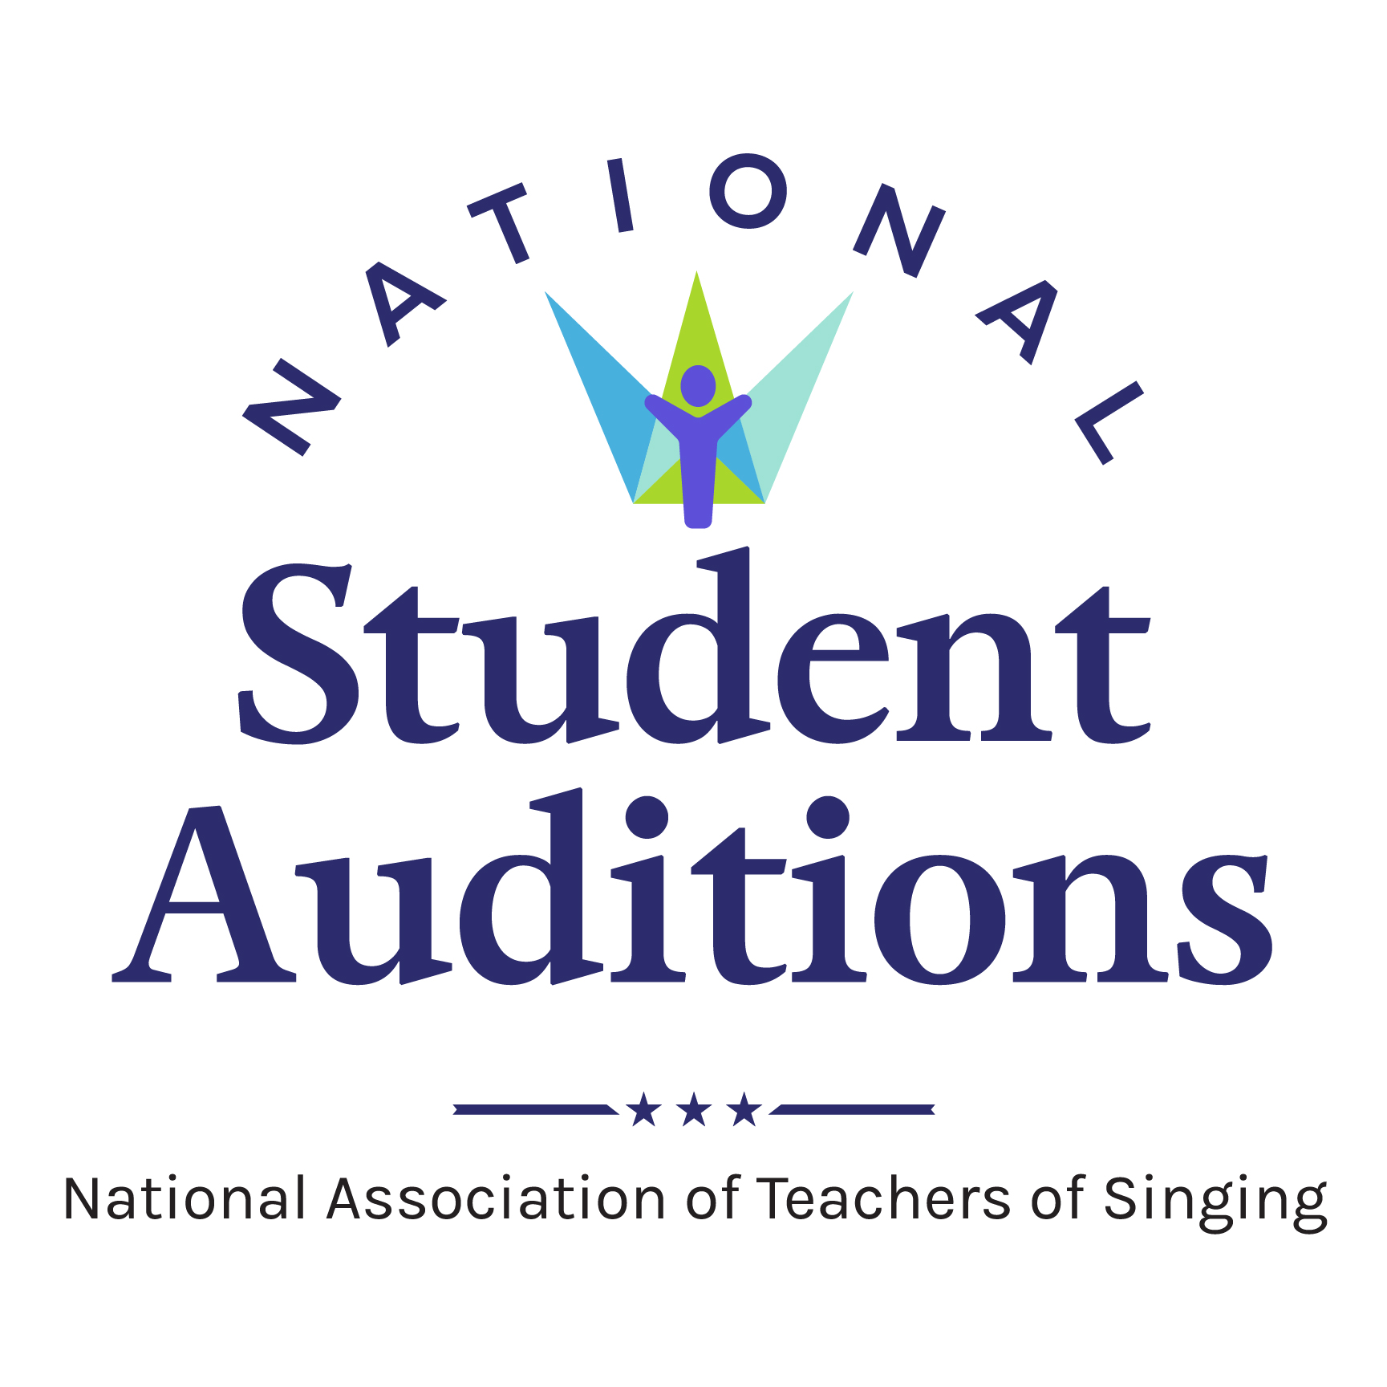INDIVIDUAL STUDENT ENTRY WORKSHEET

NATS Student Auditions: CO-WY Chapter 2024

***This worksheet is only to gather information from your students.*** *The information must be*

*submitted online by the teacher. Entry/lunch fees may be paid online or sent as a check.\**

Student’s Name: ____________________________________________________ Treble or TBB (circle one)

School: __________________________________ Cell Phone: ___________________________________

Birth date: _______________ Length of voice study (since age 18/after HS): _______________________

Email: ________________________ (indicate in years,

e.g.college freshman

would be 1 year post-high school)

**Audition Category:** Circle the category(s) this student will enter.

Please see the Auditions Handbook for the category list.

Classical Category: CL 3A-1 CL 4A-1 CL 3A-2 CL 4A-2 CL 3B-1 CL 4B-1 CL 3B-2 CL 4B-2

CL 5A CL 6A CL 5B CL 6B CL 7A CL 8A CL 7B CL 8B CL 9A CL 10A CL 9B CL 10B CL 11A CL 11B CL 12A CL12B CL 13 CL14

Musical Theatre Category: MT 3A-1 MT 4A-1 MT 3A-2 MT 4A-2 MT 3B-1 MT 4B-1 MT 3B-2

MT 4B-2 MT 5A MT 6A MT 5B MT 6B MT 7A MT 8A MT 7B MT 8B MT 9A MT 10A MT 9B MT 10B MT 11A MT 11B MT 12A MT12B MT 13 MT 14

Check here if the student will sing for “comments only”: _____

(The $15.00 entry fee is the same for both “competition” and “comments only”.)

# Pianist: REQUIRED

# **A pianist may play for no more than 10 auditions *PER DAY*.

Pianist’s name: ________________________________________________

Cell phone: ______________________________ Email: _____________________________________

If auditioning for both classical and music theater, will the same pianist play both auditions? YES or NO

If “NO,” include information for both pianists and clearly identify who will play each category.

Is the pianist also a singer/competitor in this event? YES or NO

If “YES,” the number of auditions they may play is reduced. See the Auditions Handbook for details.

**Teacher:**

If the entrant has studied with you for fewer than 8 months and had previous vocal training, you must disclose the name of the previous teacher: _______________________________________________

**Deadline:**  **Thursday, February 29, 2024**

**Register student at:**  nats.org; once logged in the link will be on your member home page.

**\*If paying by check, please consult the homepage on the registration site for information. Note that you *must* register quite early to do so.**